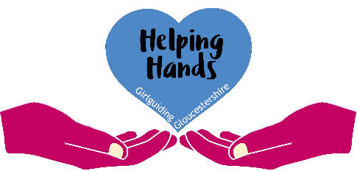
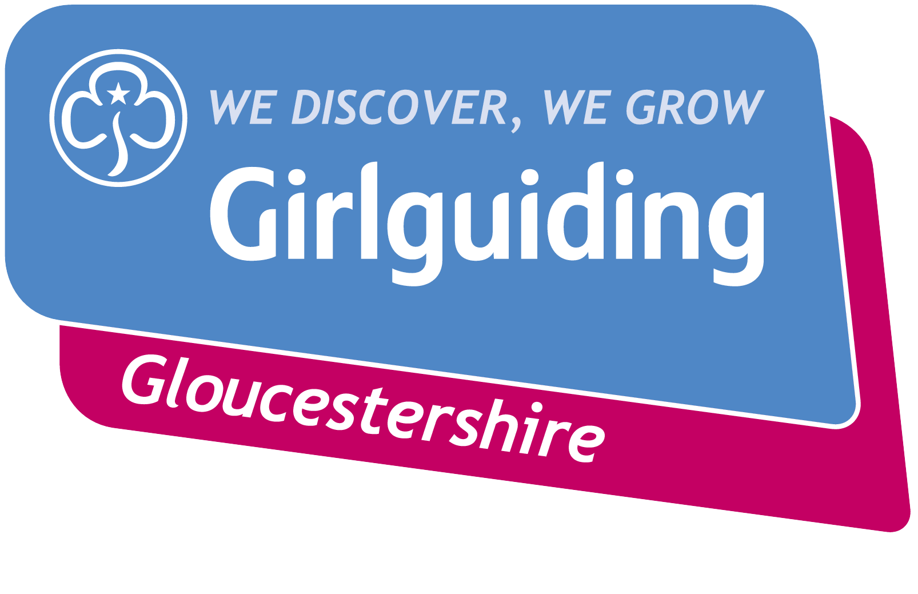

Unit Application Form for Helping Hands Grant

A unit application can only be made once in any calendar year.
Please complete the application form below if you are requesting a Helping Hands Grant on behalf of a whole unit.

Main Contact |  | Membership Number
Email address |  | Tel No.
Unit
District
Division

Please give a description of the reason for this application and what the grant will be used for. Please give as much detail as you can.
Please give details of other ways your unit has sought additional funding in the last 12 months. This might include Gift Aid, fundraising, applying for grants from other organisations, etc.
Grant amount requested |  | Does your unit claim Gift Aid?
Were your last annual subscriptions paid on time? |  | When was your last Gift Aid claim received from HMRC?

I confirm the details given above are true and correct and that knowingly making a false application would be a breach of the Girlguiding Code of Conduct.
Signed |  | Date

When submitting this application, please send a copy of the Unit’s last year’s annual accounts summary (signed by an independent verifier) and a copy of your latest bank statement.
Applications should be completed electronically and emailed to finance@girlguidingglos.org.uk
Applications can be submitted at any time of the year. There are no specific deadlines.
For County use only:
Unit accounts submitted? |  | Unit bank statement submitted?
Unit balance at year end |  | Gift Aid support required?
District balance at year end |  | Division balance at year end
Grant details
Amount of grant awarded |  | Date grant paid to unit
If no grant was awarded, please give brief reasoning

