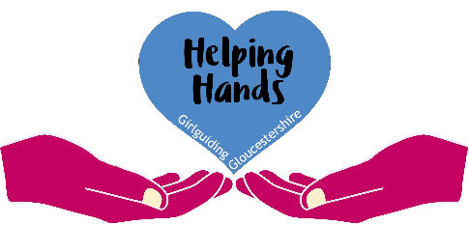
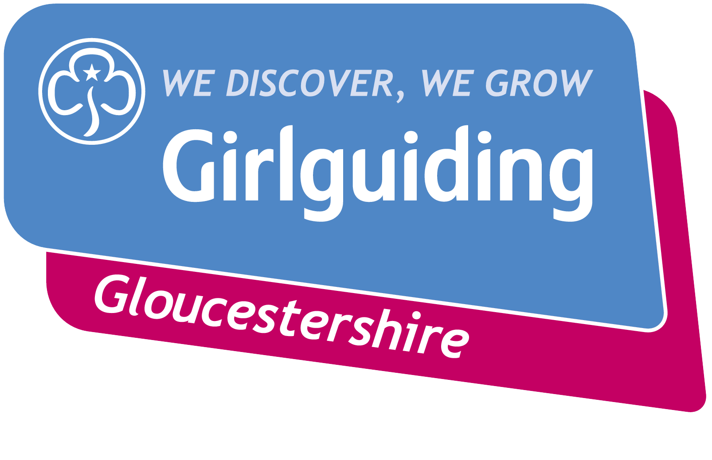

Individual Application Form for Helping Hands Grant

An individual application can be made a maximum of twice in any calendar year.
A unit Leader should complete this application to request a Helping Hands Grant on behalf of a young member or herself.

Main Contact for the application |  | Membership Number
Email address |  | Tel No.
Name of the member being supported |  | Membership Number
Unit
District
Division

Please give a description of the reason for this application and what the grant will be used for. Please give as much detail as you can.
Grant amount requested |  | Does your unit claim Gift Aid?

I confirm the details given above are true and correct and that knowingly making a false application would be a breach of the Girlguiding Code of Conduct.
Signed |  | Date

When submitting this application, please send a copy of the Unit’s last year’s annual accounts summary (signed by an independent verifier) and a copy of your latest bank statement.
Applications should be completed electronically and emailed to finance@girlguidingglos.org.uk
Applications can be submitted at any time of the year. There are no specific deadlines.

For County use only:
Unit accounts submitted? |  | Unit bank statement submitted?
Unit balance at year end |  | Gift Aid support required?
District balance at year end |  | Division balance at year end
Grant details
Amount of grant awarded |  | Date grant paid to unit
If no grant was awarded, please give brief reasoning

